**TASK EXECUTE:**

Go to AWS Console:

And click on 3 lines left side – click on all services – under compute – click on LAMBDA.

Go to IAM

Click on ROLES let side – click on Create Role

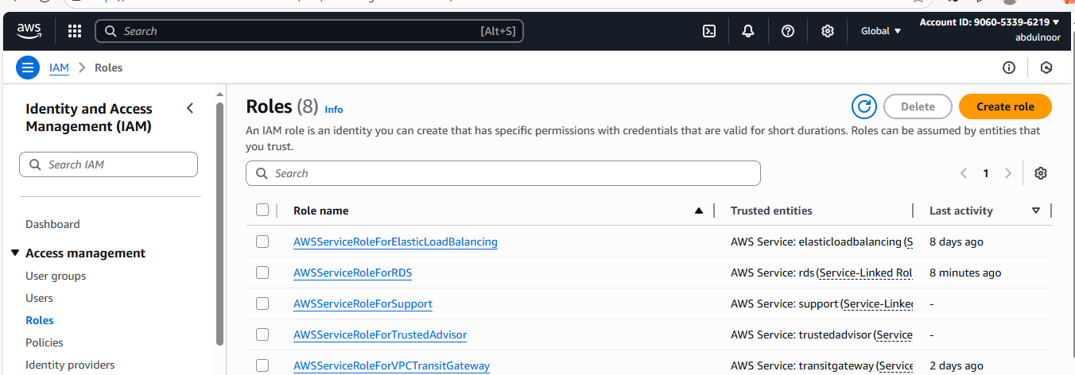

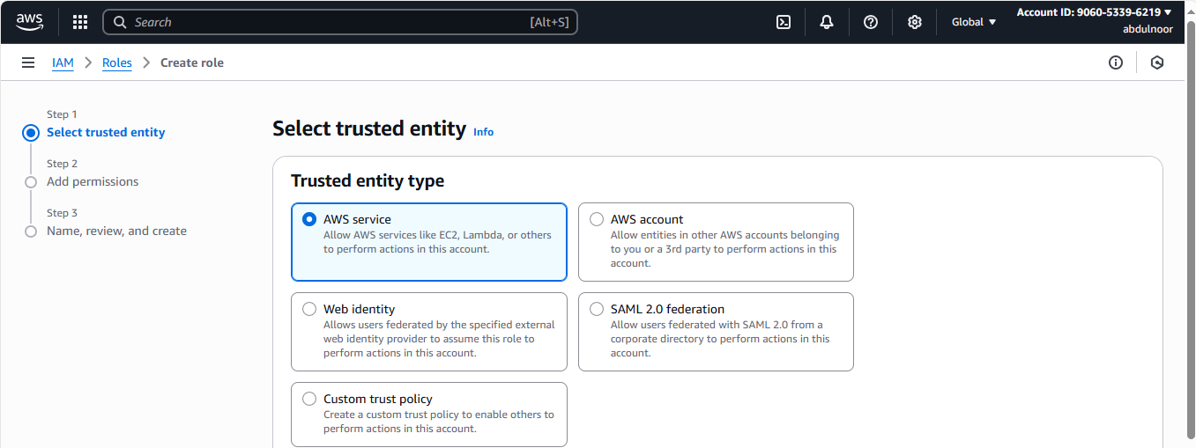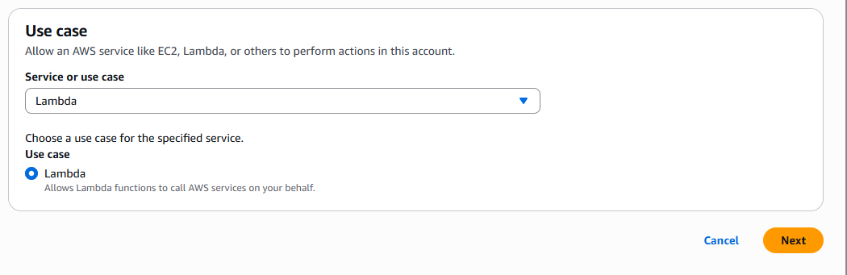

Click on Next

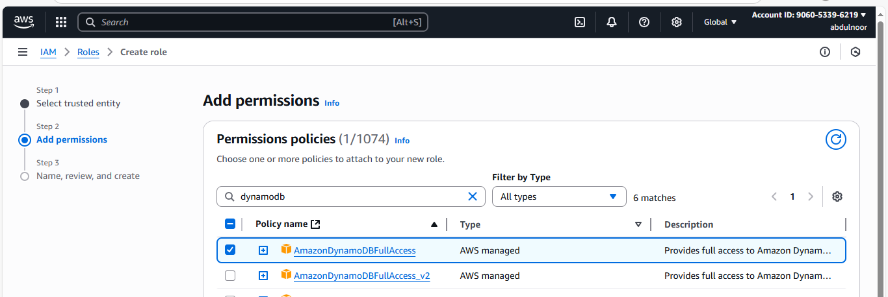

Click on Next

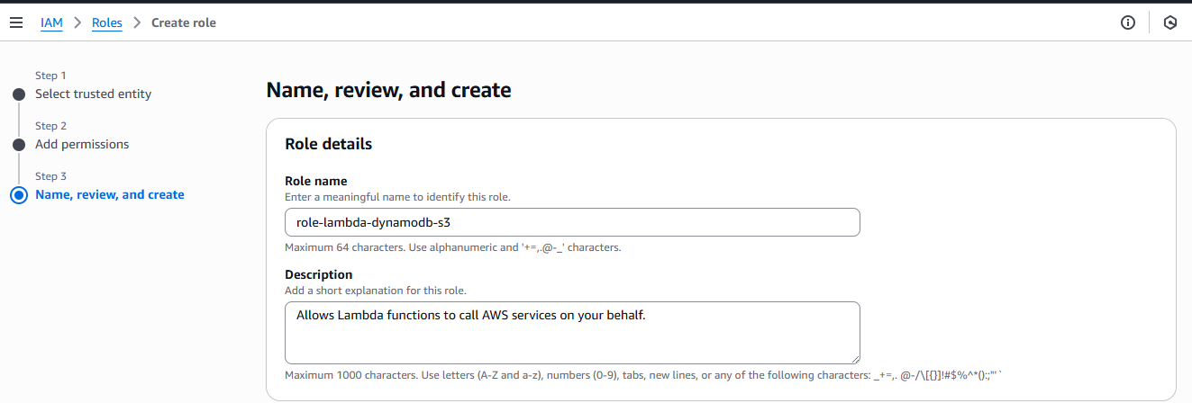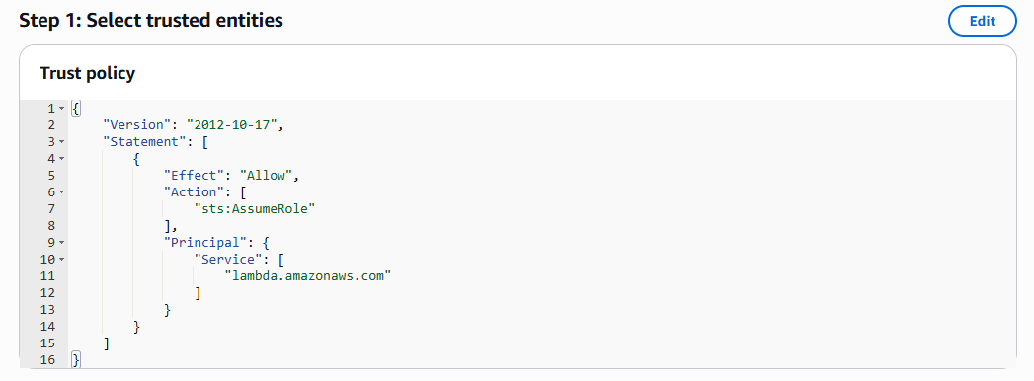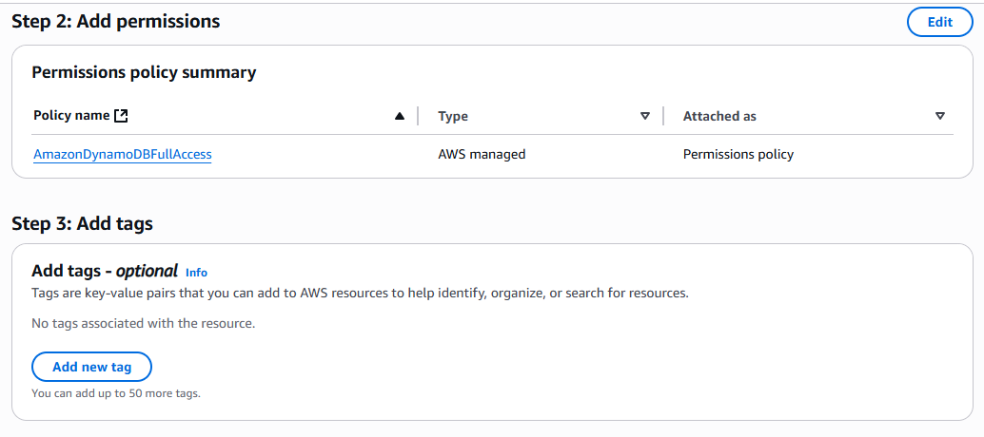

No need to do anything in the above step 1 and 2. This automatically AWS generate script for role .

Click on create role.

Now Role has ready.

2) create a S3 bucket

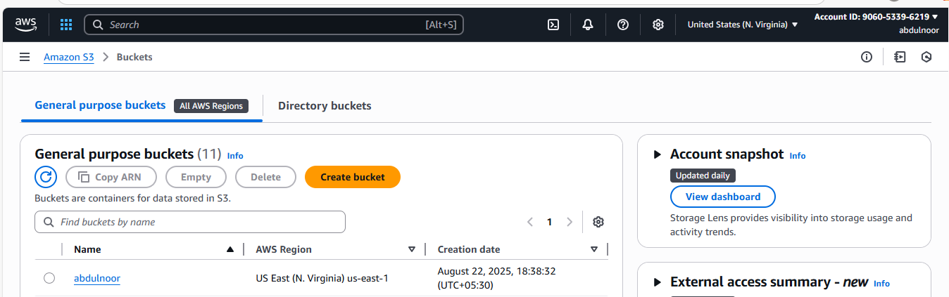

S3 bucket can create with any name because code doesn’t any work with it’s name.

Because we attach to S3 bucket in trigger and there we select the bucket.

3) click on LAMBDA under compute

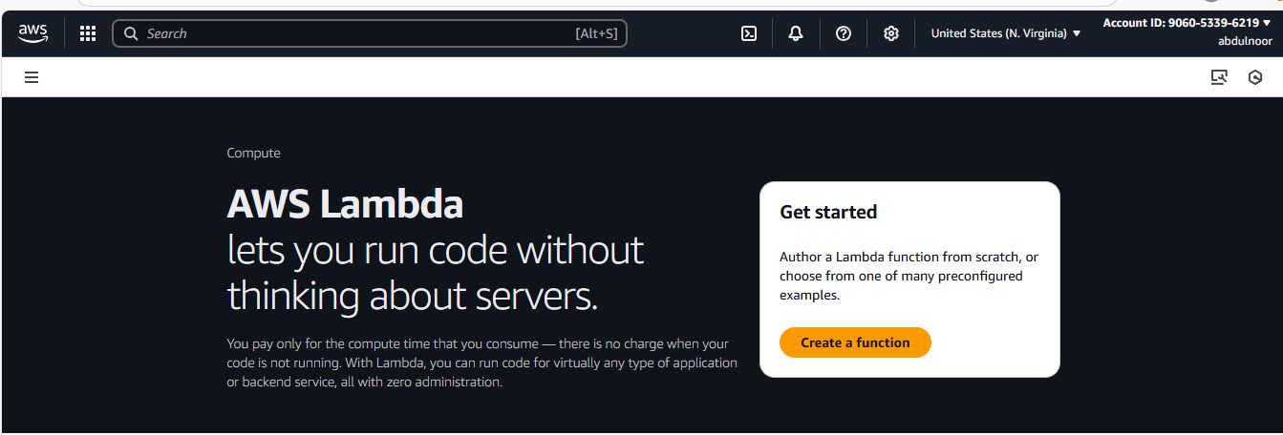

Click on create a function

See here we don’t have earlier any function

Points:

Author From Scratch : to put/attach our code we use this option.

Runtime: In which programing language you want to run your code (like python)

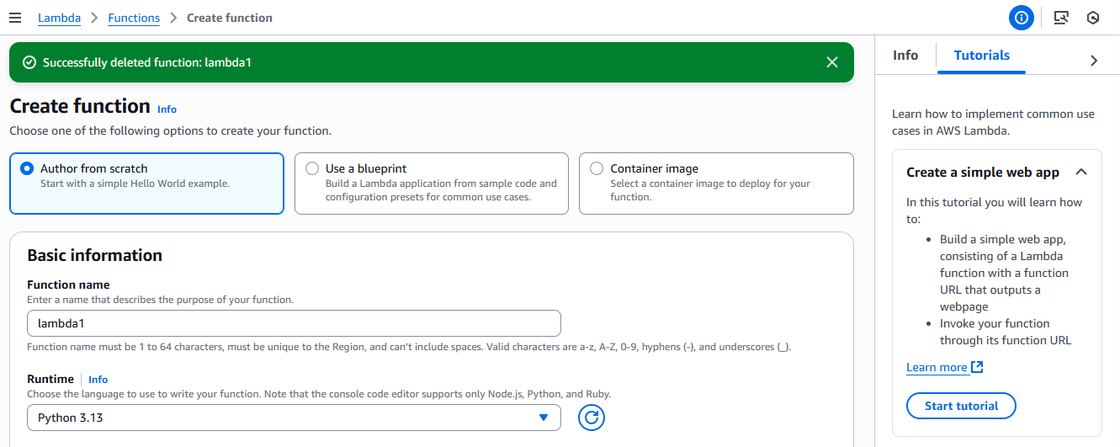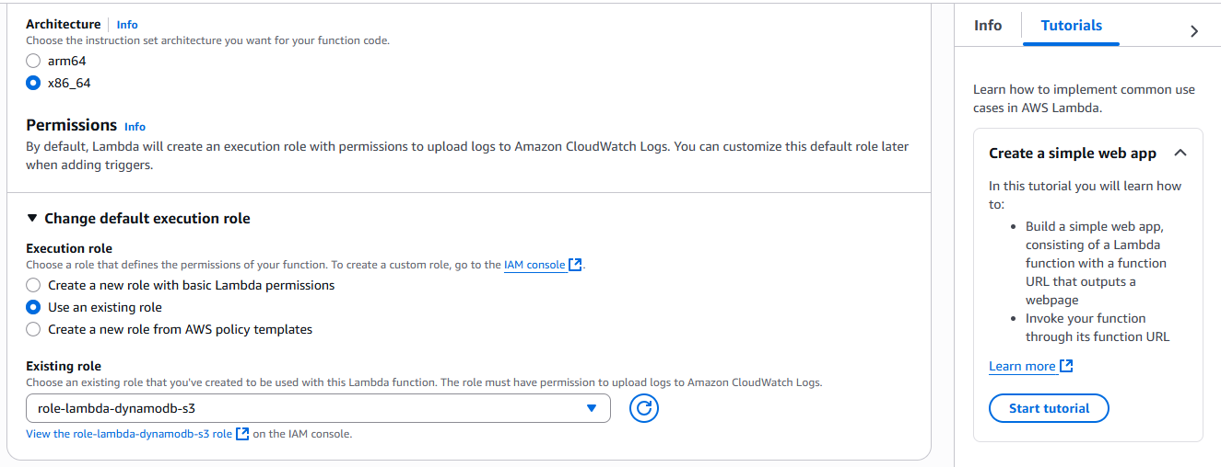

Click on create

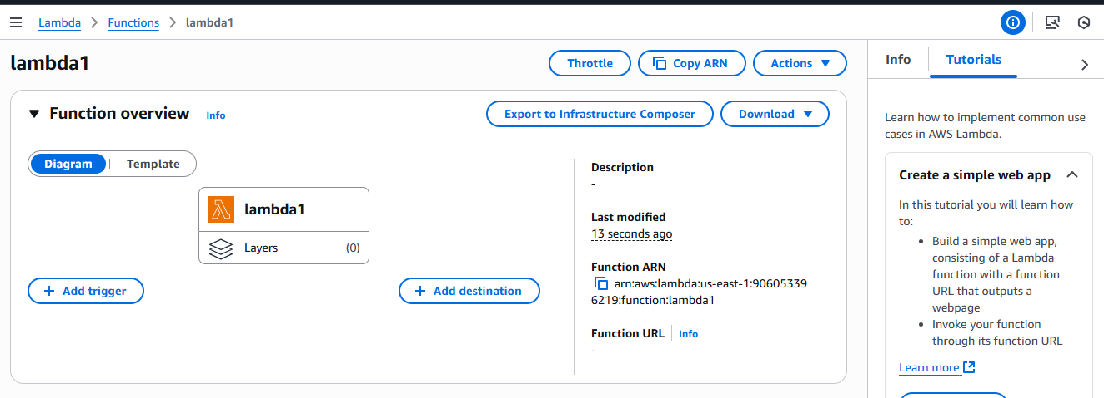

Now I have created Lambda function, name as lambda1

In let side I need add trigger (S3 bucket)

And you can see your permissions which added in the IAM role that is Dynamodb in the permission tab let side because we are using first time this function.

Go to configuration tab – click on Permission tab left side here you can your permissions in the resource summary.

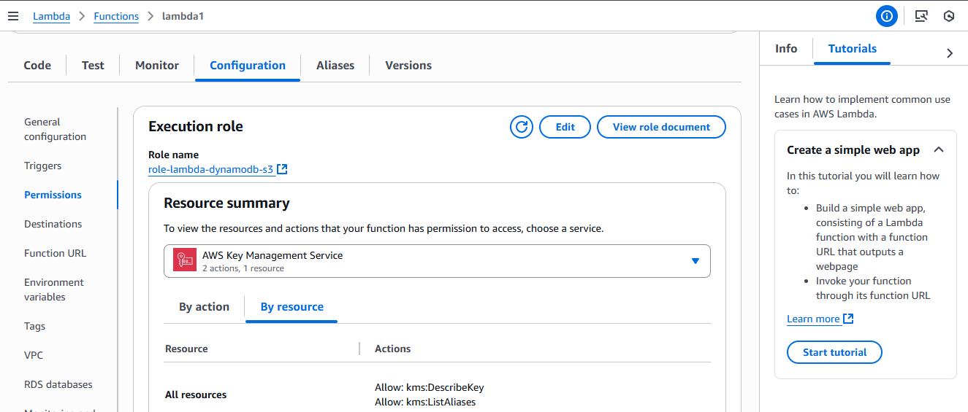

Click on code tab and remove the existing code and paste your code according to the python version. Code starts as below

import boto3

from uuid import uuid4

from typing import Any, Dict

def lambda_handler(event: Dict[str, Any], context: Any) -> Dict[str, Any]:

s3 = boto3.client("s3")

dynamodb = boto3.resource("dynamodb")

dynamo_table = dynamodb.Table("newtable")

for record in event.get("Records", []):

bucket_name = record["s3"]["bucket"]["name"]

object_key = record["s3"]["object"]["key"]

size = record["s3"]["object"].get("size", -1)

event_name = record.get("eventName")

event_time = record.get("eventTime")

# Insert item into DynamoDB

dynamo_table.put_item(

Item={

"unique": str(uuid4()),

"Bucket": bucket_name,

"Object": object_key,

"Size": size,

"Event": event_name,

"EventTime": event_time

}

)

return {

"statusCode": 200,

"body": "Data inserted successfully into DynamoDB"

}

********************************************************************************

here table name is newtable

and the id which keep in that is unique , that is partition key name

you can change according to your table name

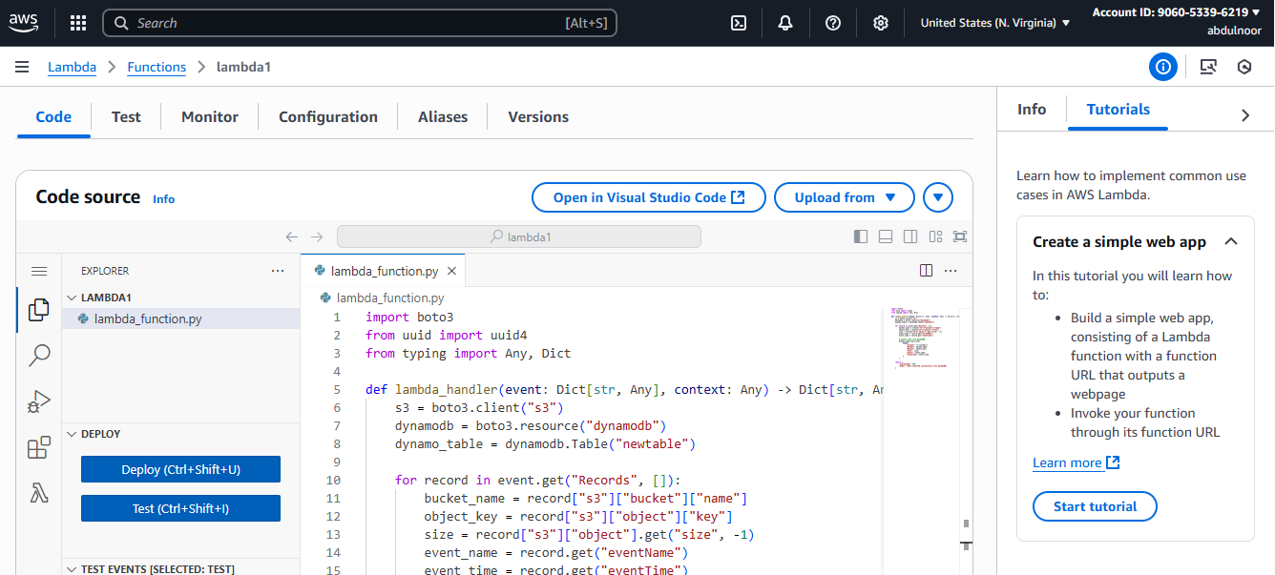

click on DEPLOY (ctrl+shift+u)

if you scroll down there is basic settings in that there is timeout setting which is maximum 15 minutes to run your code.

you can check by giving 16 minutes it wont take.

Now I need to add trigger in my lambda function

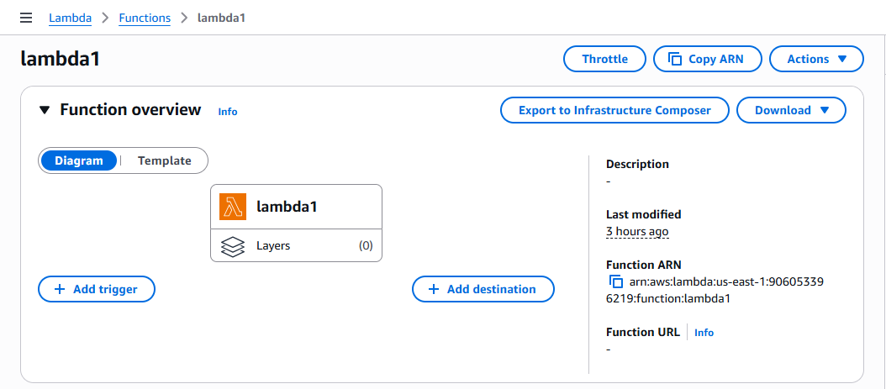

Trigger happened when event/activity occur then s3 bucket need to be trigger then S3 informed to lambda and lambda updates the all the information in dynamodb.

Ex: any data come into this bucket or Ex: object created

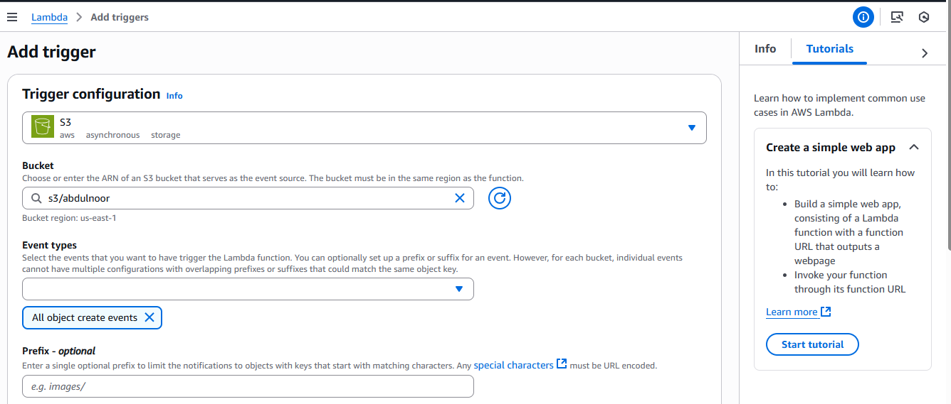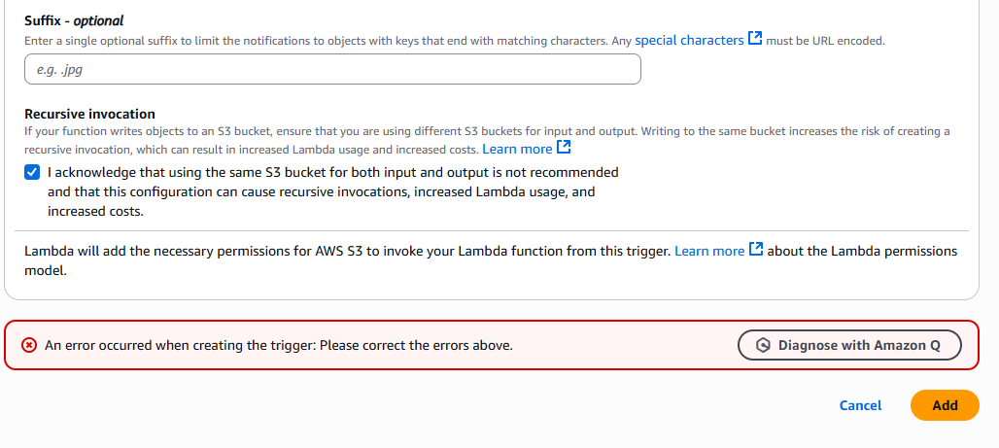

Click on add

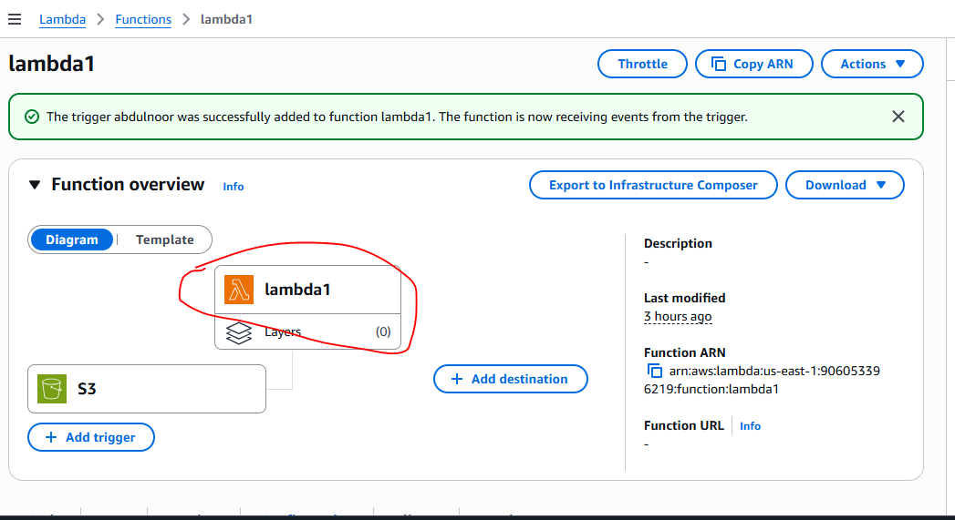

Now Lambda need to inform to Dynamodb that objects came in S3 bucket that information need to put in DDB according to my written code.

Click on lamda1 function so that below you can see here itself your written code.

Now for this we need to create dynamodb.

Now go to aws console all services – under databases – click on DynamoDB

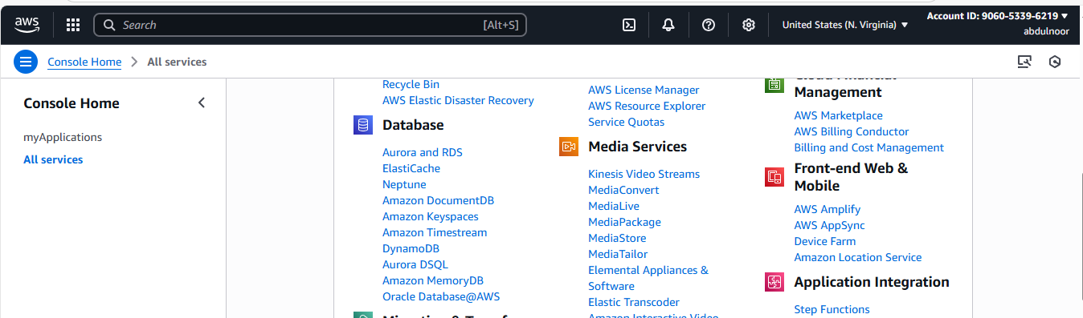

Click on create table

Give table whatever you kept in your code that is I kept newtable and item is unique

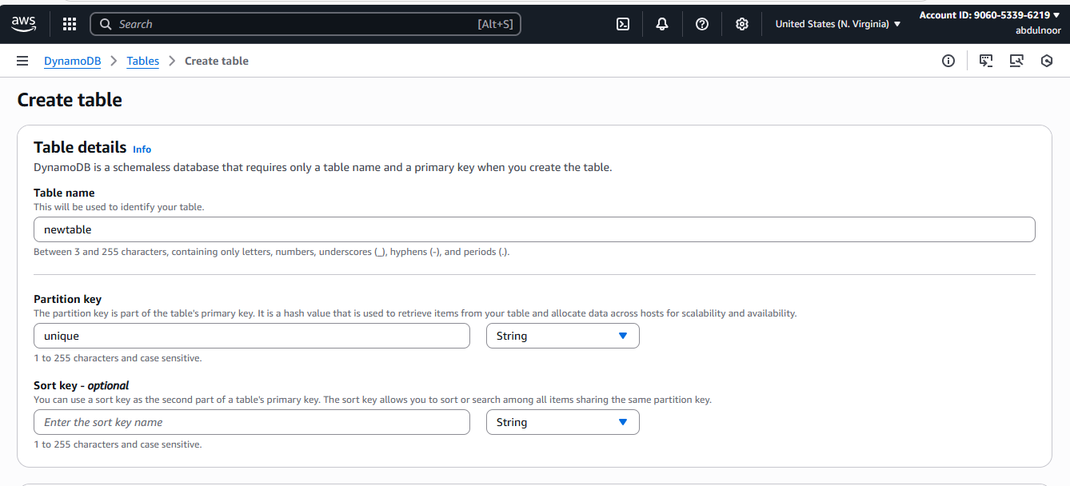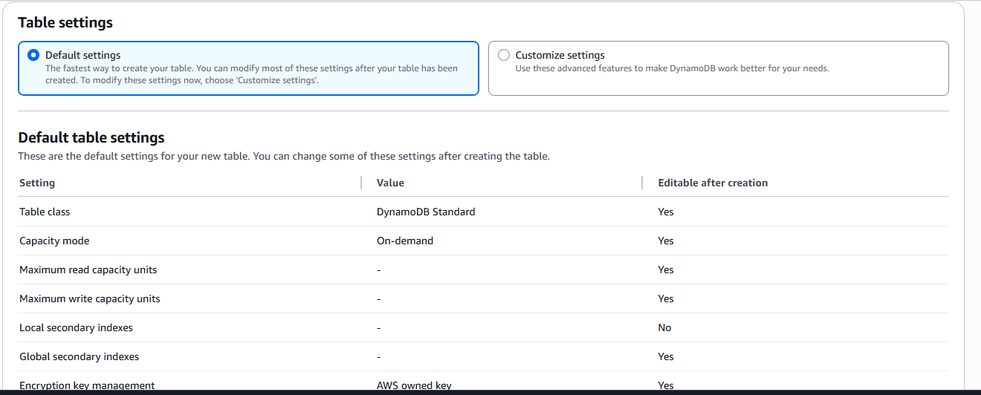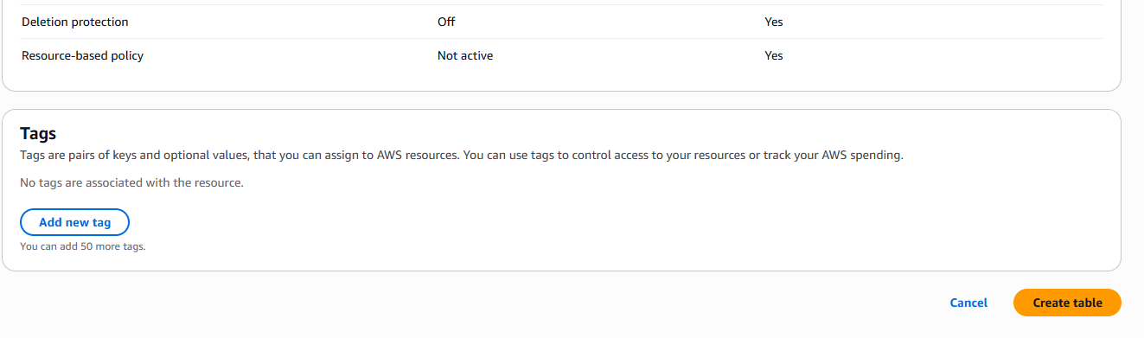

Click on create table

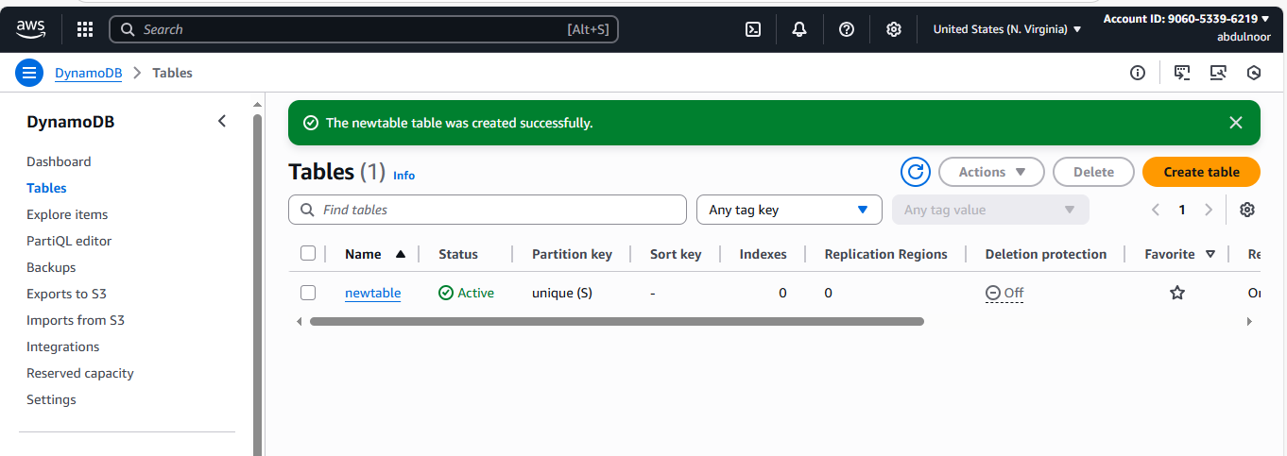

Selct your table and click Actions – click on explore items

Here you can see there is no any items in your table

Now if I keep any items in the S3 bucket then will it be any entry in DDB automatedly

Go to S3 bucket and upload item/object

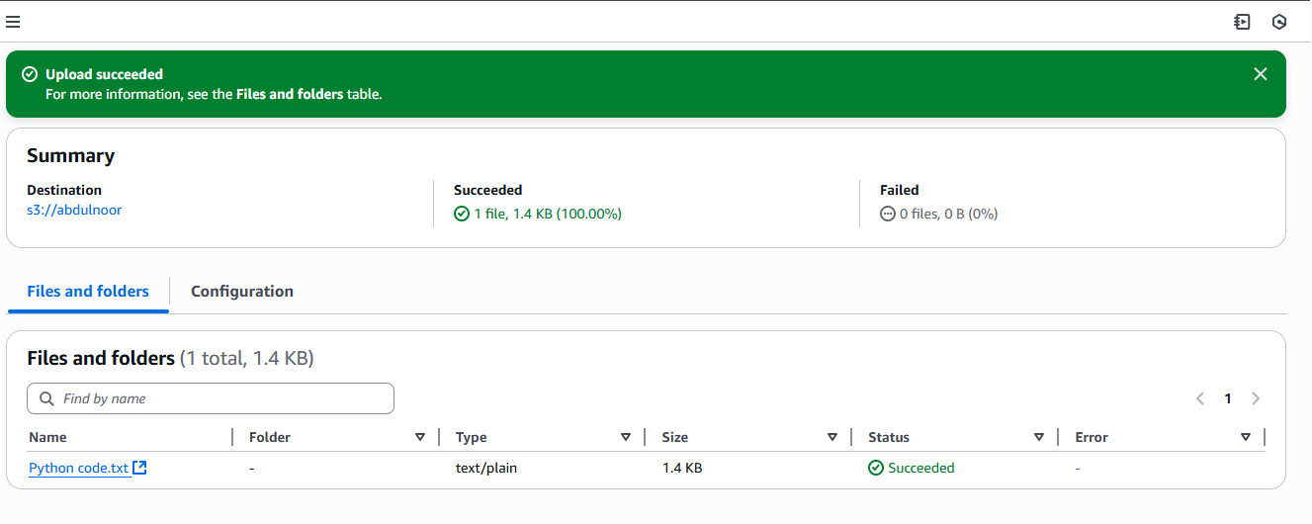

Now check in DDB any item automatically added or not

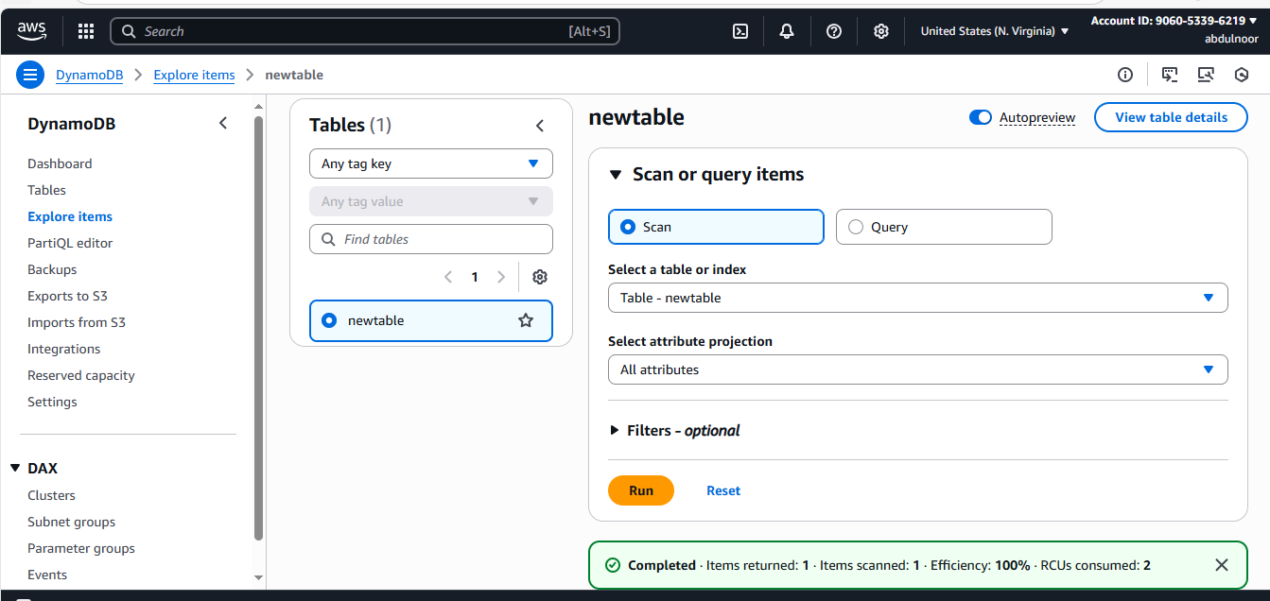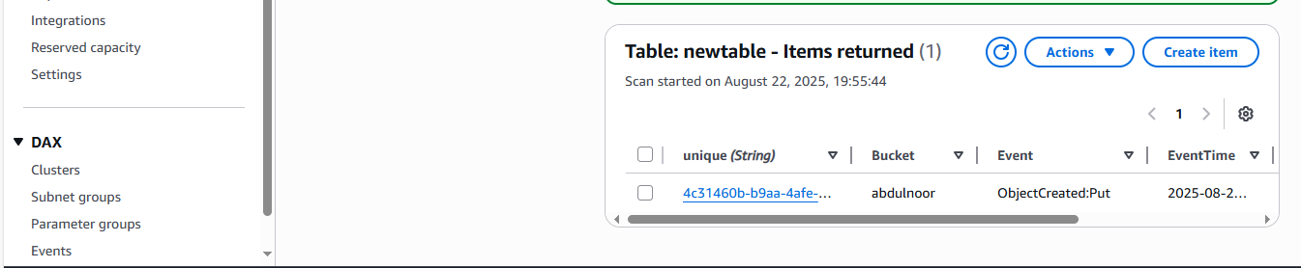

Add one more object

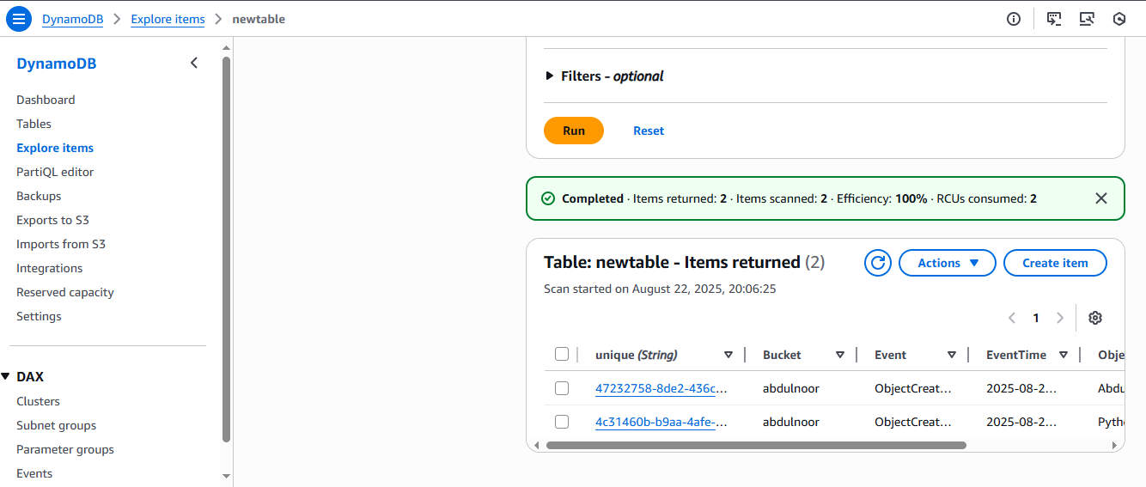

See previously it was 1 now 2 items are appearing

.